英语 九年级全册
Unit 7 | Teenagers should be allowed to choose their own clothes. | Period 3 | Content Section A Grammar Focus, 4a, 4b, 4c
教学目标要求
1．能讨论被允许做某事，如：Teenagers should be allowed to have part-time jobs.
2．能讨论不被允许做某事，如：Teenagers shouldn’t be allowed to have part-time jobs at night.
3．能表达同意和不同意，如：I agree. / I disagree.
4．能正确使用 “情态动词 + 被动语态” 结构，并完成相关语法练习，如：Should teenagers be asked to move out when they start working.
5．能正确朗读 Grammar Focus 中的句子，如：I don’t think sixteen-year-olds should be allowed to drive.

教学过程
活动 | 步骤 | 教与学活动目的及其操作 | 教学资源运用
复习  时间  2 m | 1 | 复习已学目标语。  Look at the pictures and let Ss make sentences. For example: Teenagers should be allowed to choose their own clothes. | 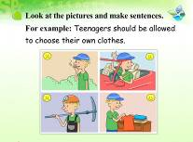
导入  时间  2 m | 2 | 导入本课标题。  教师板书或课件显示：  Unit 7 Teenagers should be allowed to choose their own clothes. Period 3 | 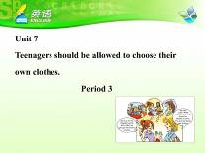
导入  时间  2 m | 2 | 引入本课语法。  Look at the four sentences. | 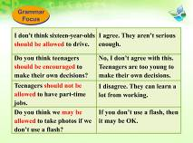
Grammar  Focus  时间  8 m | 3 | 读句子，感知目标语。  Student A and Student B, can you read the sentences in Grammar Focus for us together?  让两个学生以问答形式朗读Grammar Focus中的例句。
Grammar  Focus  时间  8 m | 4 | 总结归纳目标句式。  Look at the sentences and summarize the structure.  教师要求学生观察这些句子并归纳出含有情态动词的被动语态的构成：  should / might / must＋be＋done | 
Grammar  Focus  时间  8 m | 5 | 复习已学相似时态，帮助理解目标语。  Change the sentences into passive voice.  回顾和复习5单元和6单元学过的被动语态及其结构。 | 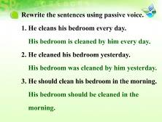
Grammar  Focus  时间  8 m | 6 | 通过时态对比，帮助学生理解。  Look at the sentences. What are the differences between them?  引导学生回忆主动语态和被动语态的区别。
Grammar  Focus  时间  8 m | 7 | 进一步细化语法点。  Look at the sentences in Grammar Focus and summarize the sentence pattern. (should / must / could be done)  让学生尝试总结。
4a  时间  5 m | 8 | 完成目标练习。  Look at 4a. Finish the sentences.  学生笔头完成4a。同时分别叫学生在黑板写出4a的答案。全班点评核对答案。 | 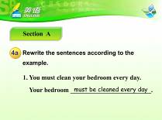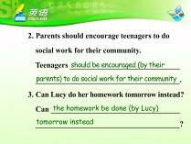  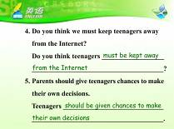
4b  时间  7 m | 9 | 观察目标语，初步感知语法点。  Read the whole passage before filling in the blanks.  让学生做之前通读一遍短文。 | 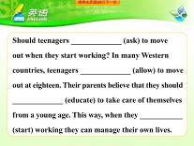  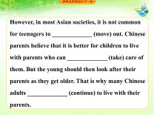
4b  时间  7 m | 10 | 完成目标练习。  Finish 4b.  完成练习并找学生站起来朗读4b并全班核对答案。 | 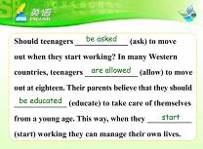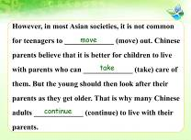
4b  时间  7 m | 11 | 回答问题，进一步理解目标语。  After you read the passage, can you answer my questions?  1．What are teenagers allowed to do in Western countries when  they are eighteen?  2．Why should they do so?  3．Do teenagers move out in most Asian societies?  4．What do Chinese parents think about it?  5．What is common for teenagers in China? Why?  6．What is their parents’ reason?  回答问题。 | 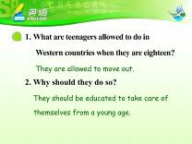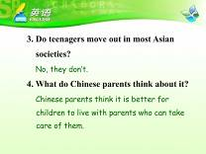  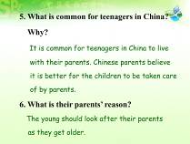
4b  时间  7 m | 12 | 归纳语法点。  Can you find the key points in the passage?  教师鼓励学生在短文中找出值得学习和掌握的词组和句型。 | 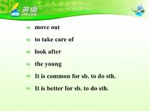
4b  时间  7 m | 13 | 如果时间允许，可以通过替换理由改变语境，小结同意和不同意的多种表达。  A: I don’t think sixteen-year-olds should be allowed to drive.  B: You are right. They are too young to drive. /  That’s right. They are not experienced. /  I agree. They are not serious enough. /  I disagree. They have to start to get experience. /  I don’t agree with you. Everything has its beginning. | 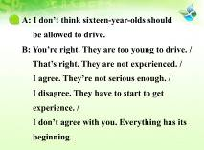
4c  时间  6 m | 14 | 头脑风暴，激活学生所学相关内容。  What do we always do in an English club? 鼓励或启发学生说：Attend English corner activities, act out English plays, sing English songs, watch English movies, read English newspapers, listen to English lectures, etc. | 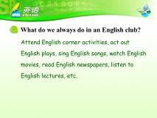
4c  时间  6 m | 15 | 小组讨论，练习目标语。  Discuss in groups. | 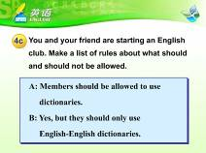
4c  时间  6 m | 16 | 小组汇报，应用目标语。  Give us your report.  小组讨论完毕后，组长汇报，全班汇总。
小结  时间  2 m | 17 | 总结本课所学目标语。  What have you learned from this lesson?  鼓励学生先自己总结，教师最后归纳。  让学生跟读Grammar Focus中的句子。 | 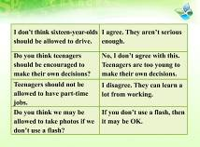
拓展  时间  7 m | 18 | 拓展练习：英语课堂的规矩。  Work in groups and make rules for our English class.  小组合作制定英语课堂规矩。注意应用should/can/could/ must be allowed to do.
作业  1 m | 19 | Homework(布置作业) | 

